CS 255 System Design Document Template

This template lays out all the different sections that you need to complete for Project Two. Each section has guidance to prompt your thinking. You will need to continually reference the interview transcript as you work to make sure that you are addressing your client’s needs. There is no required length for the final document. Instead the goal is to complete each section based on what your client’s needs are. Remove this note when you are finished, and replace all bracketed text with the relevant information.

UML Diagrams

UML Use Case Diagram

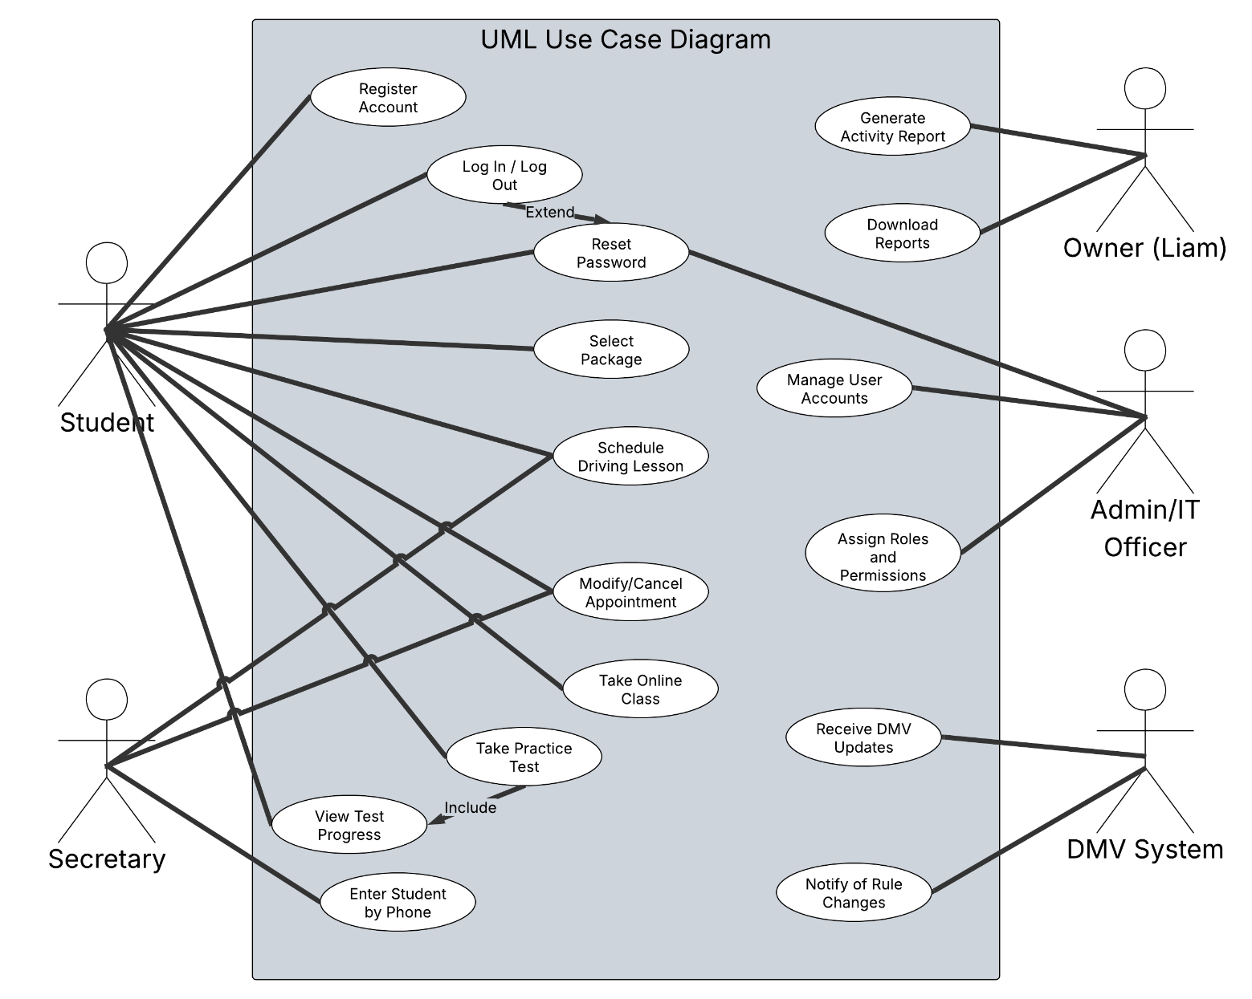

UML Activity Diagrams
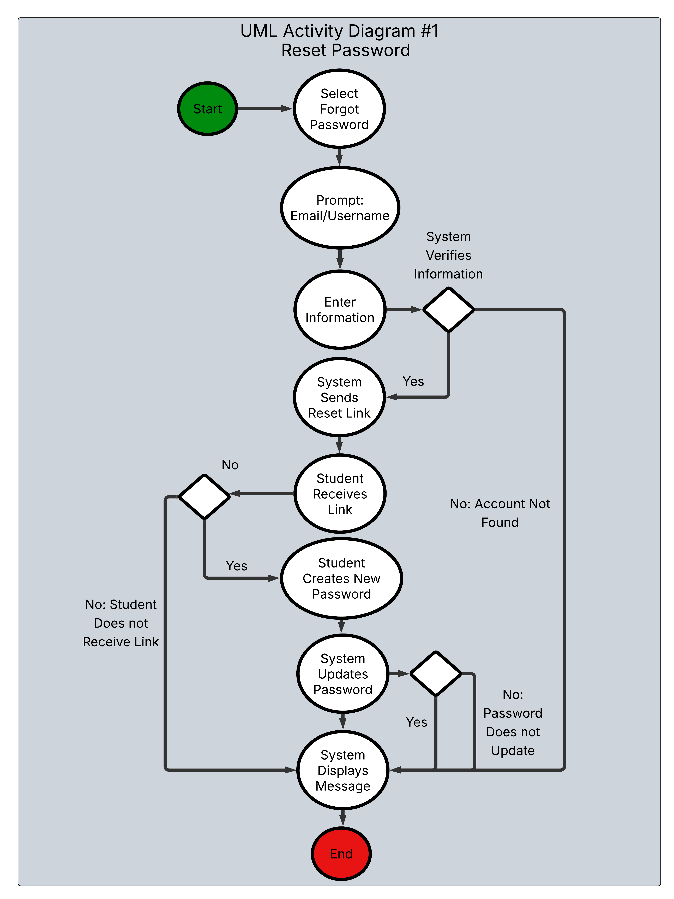
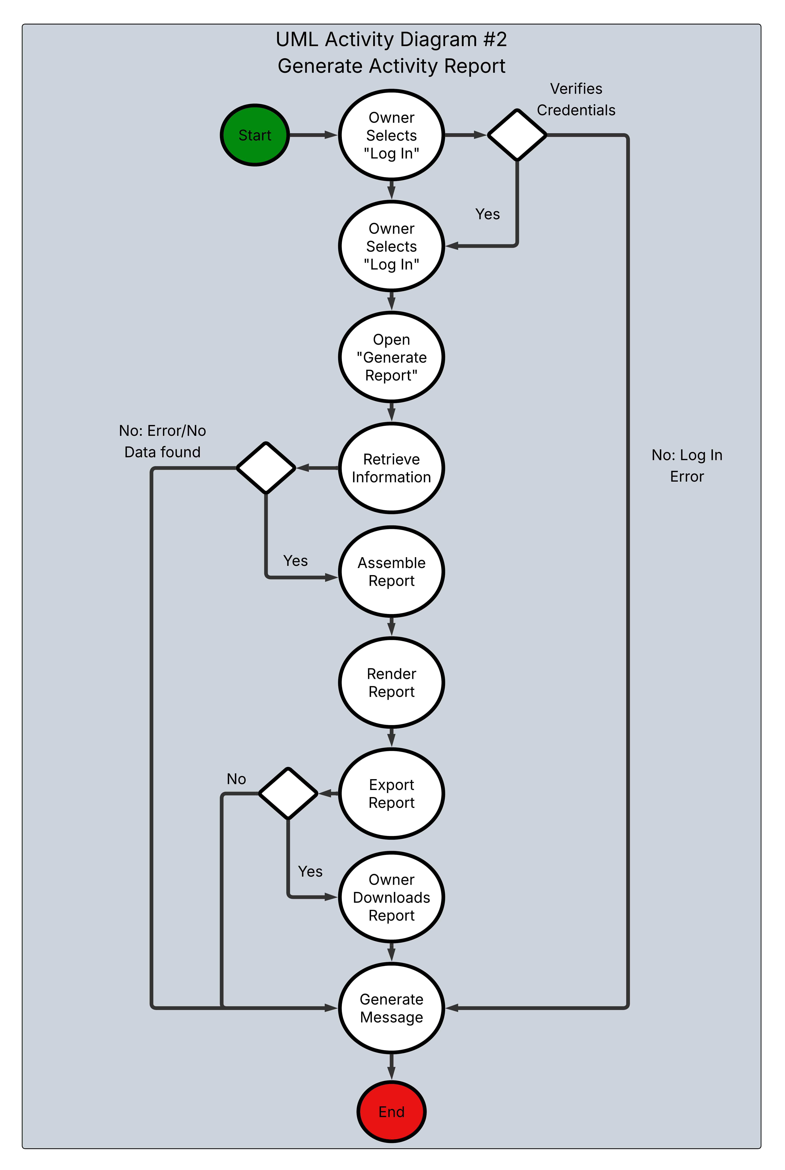

UML Sequence Diagram
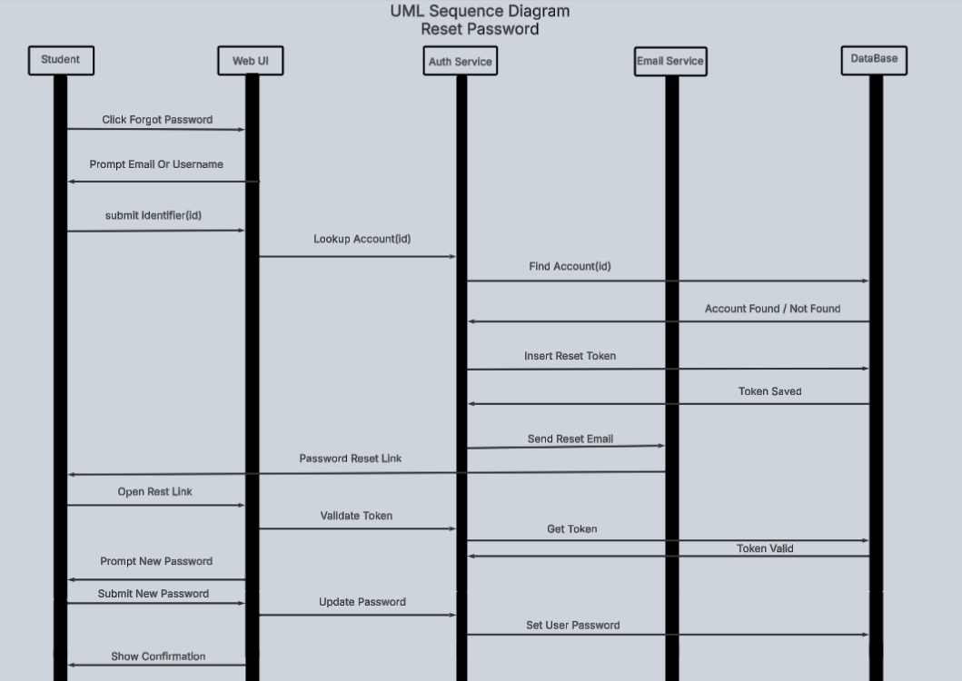

UML Class Diagram
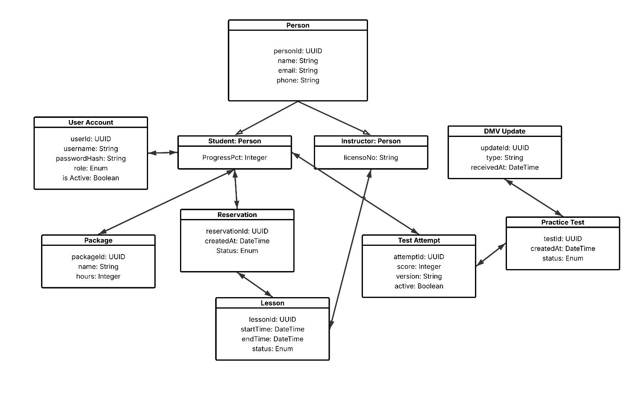

Technical Requirements
The DriverPass system will rely on a combination of server-side hardware and client-side software. On the server side, the system will run on a reliable and secure web server with enough storage and processing power to handle user data, lesson schedules, and test information. A database will store account details, appointments, and DMV updates. Regular data backups and stable internet connectivity will be part of the server infrastructure to prevent data loss and downtime.
On the client side, users will access the system through a web browser on desktop or mobile devices. The web interface will be built with HTML, CSS, and JavaScript to ensure a simple and responsive design that works across different operating systems and screen sizes.
The software for the system will include Java for the main application logic and a database management system for data storage. Communication between clients and the server will be done over HTTPS for security, and passwords will be stored using encryption or hashing methods. User roles will control access to specific features, and secure APIs will allow communication with the DMV system.
For development tools, the system will be designed and tested in Eclipse using Java, and Lucidchart will be used to create and maintain UML diagrams. This combination of tools and infrastructure will make the DriverPass system reliable, scalable, and secure.

